**Descriptive statistics:**

Mean absolute deviation:

1. It is used to calculate the deviation between the data point and mean value.

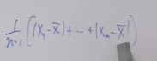

|x1-x-| > || represents absolute value of difference between data and mean value(x- (x bar))

1. Since it is not squaring the difference between the data and mean we can find the outliers easily, which is not possible in standard deviation. So it is mostly used in machine learning algorithms

Inter quartile range: Q3 –Q1 (75% minus 25%)

Range is max- min

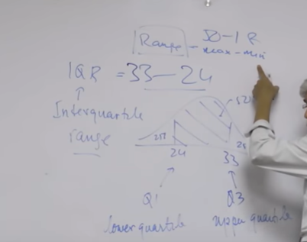

With the 5point summary (mean, 25%, 50%, 75%.max) we can find the location which is median and two measures of dispersion (range and Inter quartile range).

Those two were twisted to give summary number, which is mean, and range number.

So the conclusion is half of my customer is between the age of 24 and 33 with the difference of 9years range which I am interested in which is 25%to 75% (interquartile range).

Therefore, when building the model we have to make sure that model performs for this 33 old and also for 24-year old.50 year old may or may not okay with the model, which is the maximum value since we are interested only with, inter quartile range.

Visualization:

Numerical plot as y-axis:

Histogram used for frequency or count.

Box plot used to identify the outliers which is plotted between categorical column (gender) in the x axis and numerical (age ) in y axis means how gender male and female got distributed for the age.

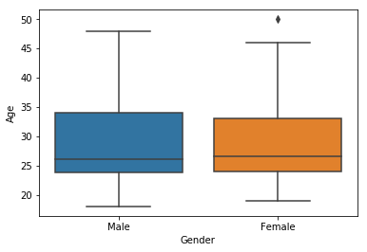

In the whisker plot, lower and upper line is min and max.

lower line is marked at min value from describing the data.

upper line is marked with the length l=1.5 * IQR (inter quartile range) from 75% line of the box

Box is plotted between IQR 25% Q1 to 75% Q3.Middle line in the box is median (50%).

The records which are higher than upper line of whisker plot is called as outliers.

Categorical variables:

Does male and female have the same preference while getting the treadmill?.

The answer is below.

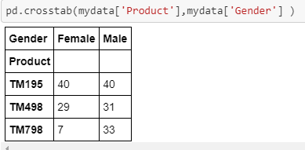

Is there any preference while purchasing the tread mill based in the marital status?

The answer is below.

